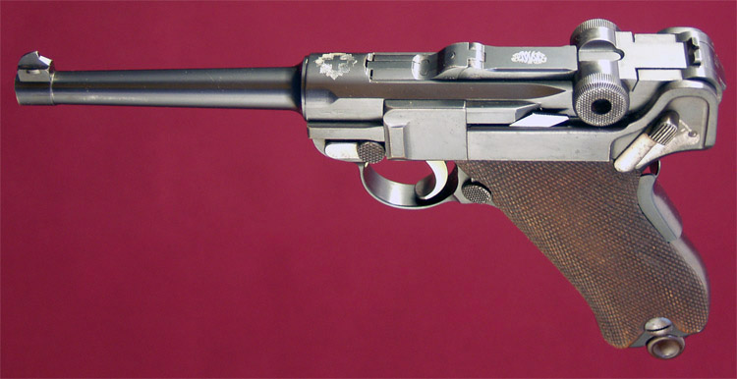
This is a 7.65mm Classic Luger squeeze grip 1906 Swiss Commercial manufactured by DWM with the 120mm (4.75") Barrel for the Swiss commercial market. Numbered in the DWM 5 digit commercial series that is the one of the best models you can get. This Luger has the new model frame and no stock lug. (781)

In 1897 Georg Luger personally demonstrated the Borchardt automatic pistol. The conclusion of the Swiss Kriegamaterialverwaltung was that the Borchardt was too big, had poor balance and too complex. However the 7.65mm cartridge was an overwhelming success.
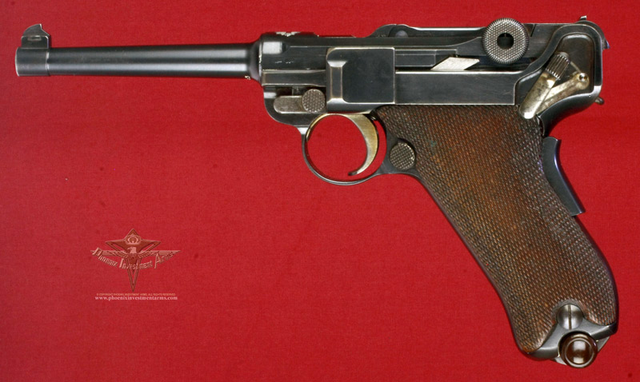
The DWM Monogram (Deutsche Waffen-und Munitionsfabriken AG) on the 1st toggle link and the Swiss Cross in Sunburst over the Chamber. There are no proof marks other than the Swiss Cross that appears on the left side of the barrel; two digits of the serial number are on the rear toggle link along with the "V" sight. We provide extensive pictures so you can access the percentage of bluing; this model has a hold open latch and all matching numbers.
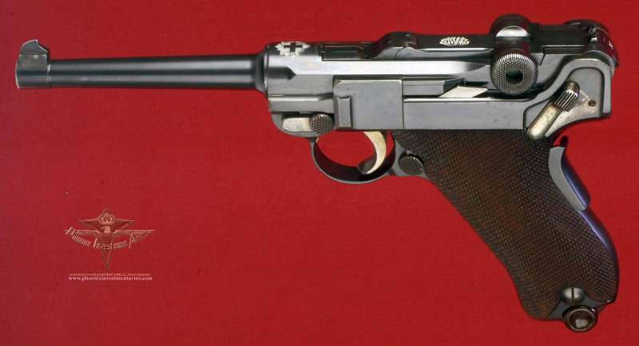
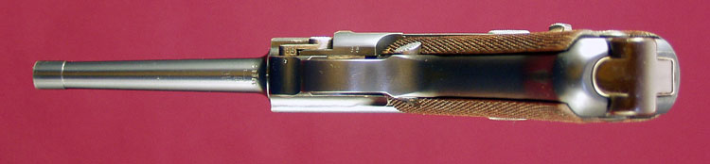
In 1897 Georg Luger personally demonstrated the Borchardt automatic pistol. The conclusion of the Swiss Kriegamaterialverwaltung was that the Borchardt was too big, had poor balance and too complex. However the 7.65mm cartridge was an overwhelming success.  In 1898 Georg Luger returned with the first of the Borchardt-Lugers (two were thought to be submitted.) The Swiss were truly impressed by the rapid fire of the Luger with hardly a misfire. Another trial was held in 1899. Again the Swiss were impressed and ordered 20 of these pistols for extensive field testing asking Georg Luger to lighten the pistol.  The Swiss were the first to adopt the Parabellum for its military service on May 4th, 1900 and so began the production of the worlds most recognized handgun. The original order had hand engraved Federal Crosses and approximately the first 900 are believed to be delivered with the un-relieved magazine. | 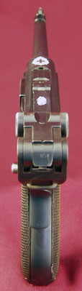
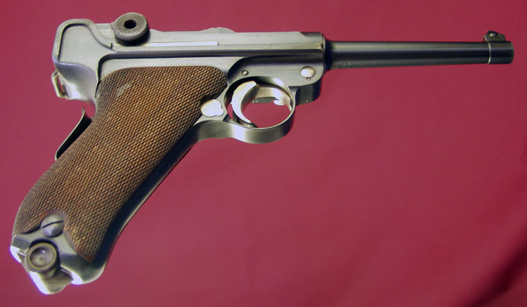
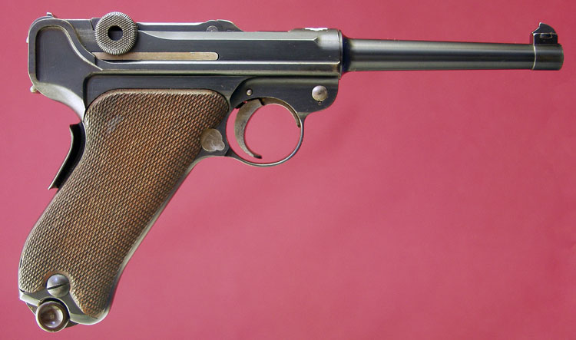
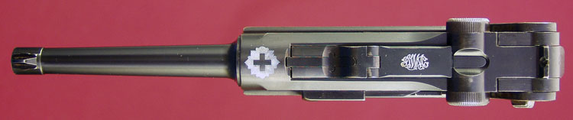
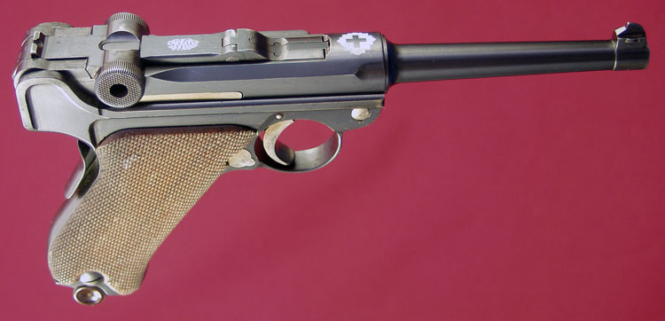
All 7.65mm Lugers have have four-groove rifling with a right-hand twist of one turn in 250mm. The inside of this barrel is very strong with still shiny finish.

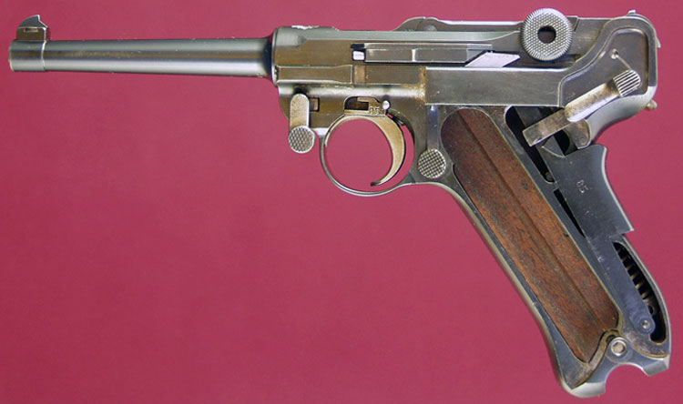
Here is the exposed gun with all the numbers matching, in excellent condition reflecting 100 years of care and demonstrating the elements of craftsmanship that last.
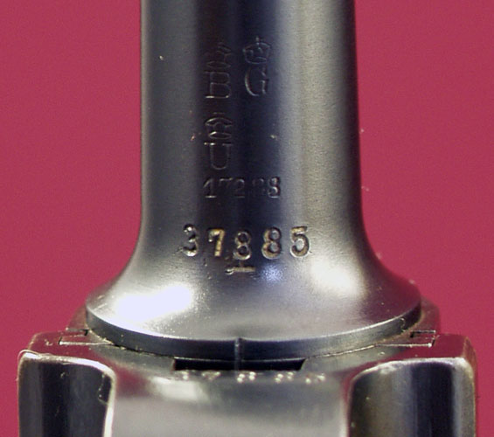
Collectors prize the guns that are BUG proofed. The Crown B means the barrels were tested using a heavier load in accordance with the 1892 proof law. The Crown U means it was inspected after assembly and the Crown G means a rifled barrel.
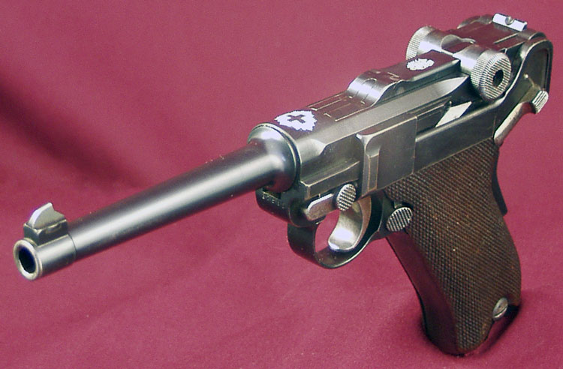
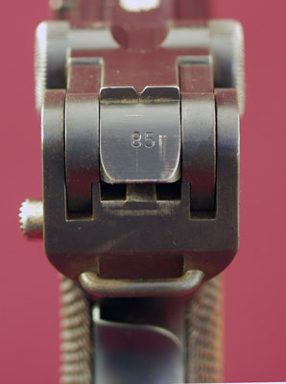 | 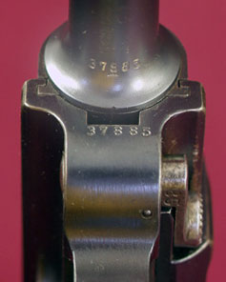  Note: The civilian contract serial number and narrow front trigger guard.
Most of the rear sights were modified by the Swiss into a "U" instead of the German produced "V". This is one that is unaltered, indicating that these were German manufactured and with no Swiss Cross proof this is truly a commercial.
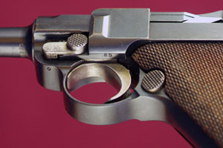 | 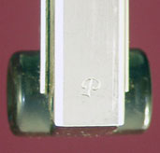
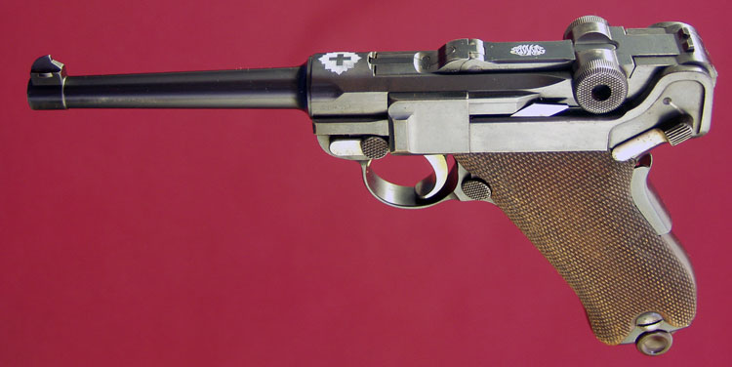
Commercially marked in the "hidden" manner with the concealed serial numbers, all matching the magazine is the commercial style with the Swiss markings.

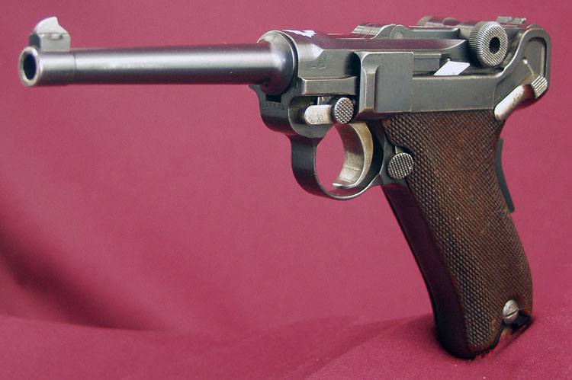
This Luger is identified as a curio and can be send directly to C&R licensees and above. Questions to: josef@phoenixinvestmentarms.com . We strive to provide pictures so you can judge for yourself if the gun meets your criteria. This Luger is offered for $5,895.00 in an over the counter cash transaction. Thanks for looking.

